**MY SQL PROJECT : SECOND HAND CAR DEALER**

CREATE SCHEMA CAR ;

IMPORT CSV FILE

GO TO TABLE THEN IMPORT TABLE DATA IMPORT WIZARD

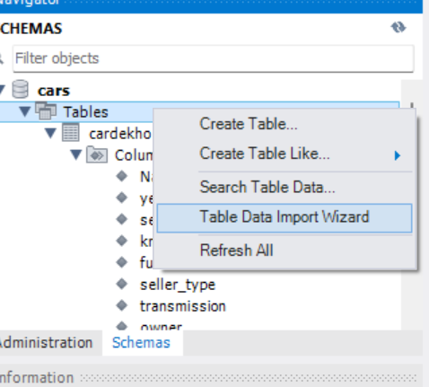

IMPORT FROM FILE AND CLICK ON NEXT

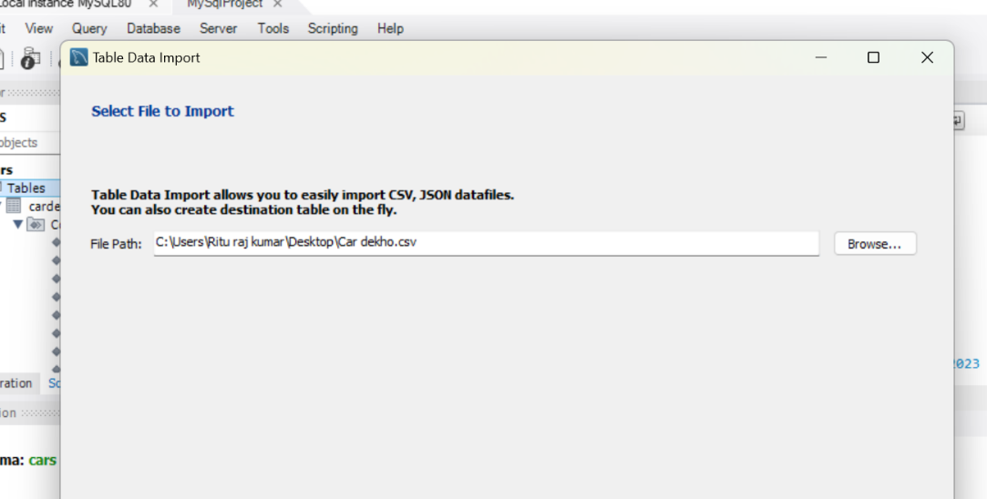

YOU CAN CHANGE THE NAME OF TABLE IF YOU WANT AND AFTER THAT CLICK ON NEXT

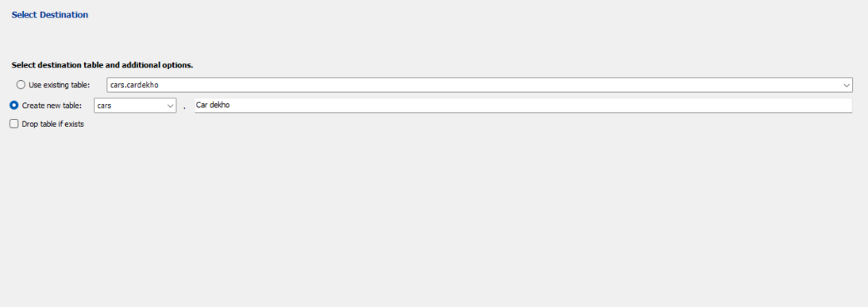

CLICK ON NEXT

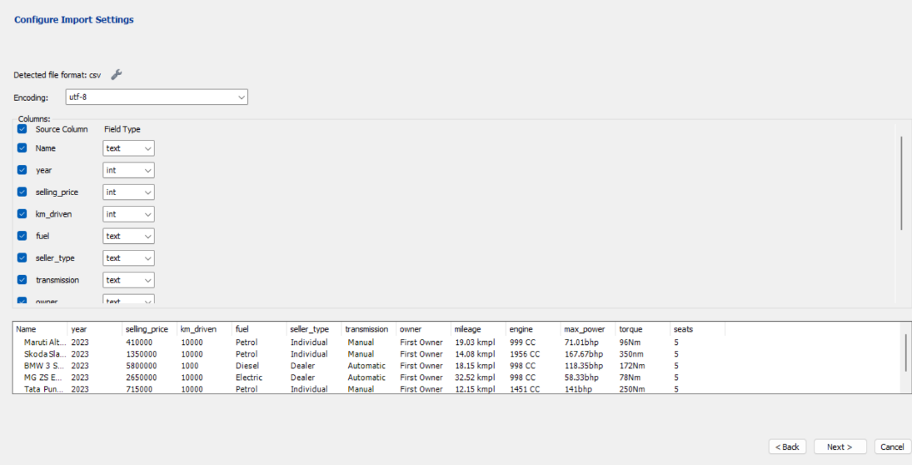

CLICK ON NEXT

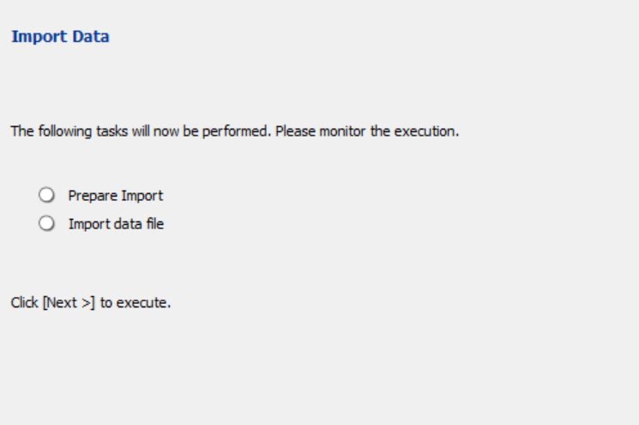

THEN YOUR CSV FILE IS READY YOU CAN PERFORM CERTAIN SQL OPERATION

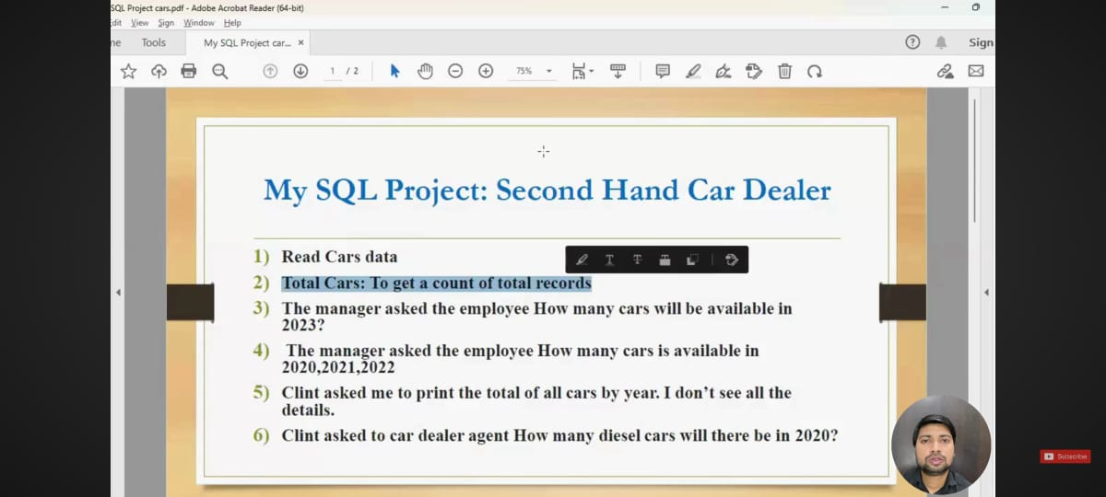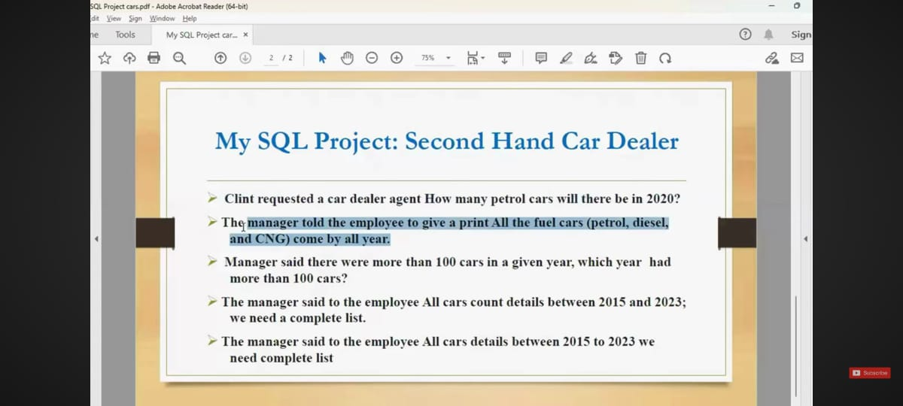

CODE :-

USE CARS;

DESC CARDEKHO;

# Q.1 READ CAR DETAILS

SELECT * FROM CARDEKHO ;

# Q.2 TOTAL CARS : TO GET A COUNT OF TOTAL RECORDS

SELECT COUNT(*) AS TOTALCARS FROM CARDEKHO ;

# Q.3 THE MANAGER ASKED THE EMPLOYEE. HOW MANY CAR WILL AVAILABLE IN 2023 ?

SELECT COUNT(*) AS CARAVAILABLE FROM CARDEKHO WHERE (YEAR = 2023);

# Q.4 THE MANAGER ASK THE EMPLOYEE HOW MANY CAR ARE AVAIBLE IN 2020 , 2021 , 2022

SELECT YEAR , COUNT(*) FROM CARDEKHO WHERE YEAR IN(2020, 2021 , 2022) GROUP BY YEAR ;

# Q.5 CLIENT ASKED ME TO PRINT OF ALL CAR BY YEAR . I DONT SEE ALL DETAIL

SELECT YEAR,COUNT(*) AS TOTALCAR FROM CARDEKHO GROUP BY YEAR ;

# Q.6 CLIENT ASKED TO CAR DEALER AGENT HOW MANY DIESEL CARS WILL BE THERE IN 2020 ?

SELECT YEAR , COUNT(*) AS TOTALCARIN2020 FROM CARDEKHO WHERE YEAR = 2020 AND FUEL = "DIESEL";

# Q.7 CLIENT ASKED TO CAR DEALER AGENT HOW MANY PETROL CARS WILL BE THERE IN 2020 ?

SELECT YEAR , COUNT(*) AS TOTALCARIN2020 FROM CARDEKHO WHERE YEAR = 2020 AND FUEL = "PETROL";

# Q.8 THE MANAGER TOLD THE EMPLOYEE TO GIVE A PRINT ALL FUEL CAR(PETROL , DIESEL , CNG ) COME BY ALL YEAR .

SELECT YEAR ,COUNT(*) FROM CARDEKHO WHERE FUEL IN ("PETROL", "DIESEL" , "CNG") GROUP BY YEAR ;

# Q.9 MANAGER SAID THERE WHERE MORE THAN 100 CARS IN GIVEN YEAR , WHICH YEAR HAD MORE THAN 100 CARS ?

SELECT YEAR FROM CARDEKHO GROUP BY YEAR HAVING COUNT(YEAR)>100 ;

# Q.10 THE MANAGER SAID TO EMPLOYEE ALL CARS COUNT DETAIL BETWEEN 2015 AND 2023 . WE NEED COMPLETE LIST .

SELECT COUNT(*) FROM CARDEKHO WHERE YEAR BETWEEN 2015 AND 2023 ;

# Q.11THE MANAGER SAID TO EMPLOYEE ALL CARS DETAIL BETWEEN 2015 AND 2023 . WE NEED COMPLETE LIST .

SELECT * FROM CARDEKHO WHERE YEAR BETWEEN 2015 AND 2023 ;